# Developed By

* Monojit Laha (monojit.Laha@cognizant.com)
* Swadhin Mukherjee ([Swadhin.mukherjee@cognizant.com](mailto:Swadhin.mukherjee@cognizant.com))

# Project Diagram

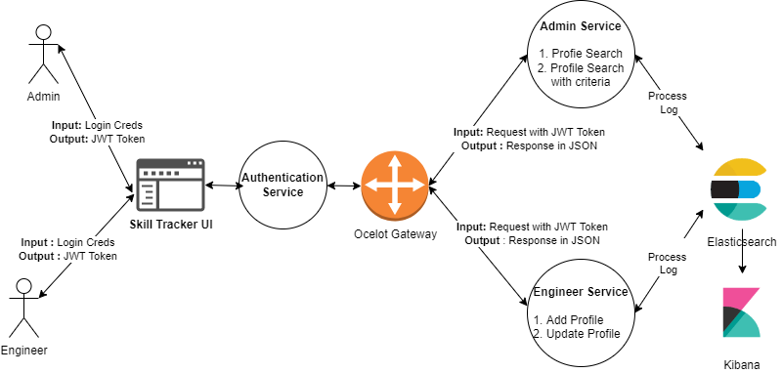

# Git Repos

* **Authentication Service -** <https://github.com/monojitlaha/jwt-authentication-service.git>
* **Ocelot Gateway Service** - <https://github.com/monojitlaha/skill-tracker-apigw.git>
* **Admin & Engineer Service** - <https://github.com/monojitlaha/skill-tracker-service.git>
* **Angular UI -** <https://github.com/monojitlaha/skill-tracker-app.git>

# Angular Component Interaction

